**Gen AI Movie Recommender System - Chatbot:**

**1. Problem Statement / Objective:**

The Objective of this Project is to build a Movie Recommender System which will provide a list of movies title to user based on the user requirements. We have a Movies Data set which contains around 5000 movies details. We will be building a Chatbot which will accept user inputs such as actor name, year of release, country, language, genre to provide user list of movies.

**2. Understanding the Movies Dataset:**

The movies data set contains around 5000 list of movies, and it has lot of columns, we will be using few sets of columns for our needs, the list of columns we will be using for the current project are:

# Column Non-Null Count Dtype

--- ------ -------------- -----

0 director_name 4924 non-null object

1 genres 4924 non-null object

2 actor_name 4917 non-null object

3 title_year 4924 non-null float64

4 imdb_score 4924 non-null float64

5 movie_title 4924 non-null object

6 language 4924 non-null object

7 country 4923 non-null object

We will be extracting details from the User input such as below to extract the movies name

- genre

- actor_name

- language

- country

- year of release

**3. System Design:**

For Building the Movie Recommender Chatbot , we are considering few inputs from the user to extract movie details those specific inputs will be extracted in the form of json object in the end, below are those inputs:

{'actor_Name':'values','movie_released_year':'number','genre:'values','language':'values','country':'values'}

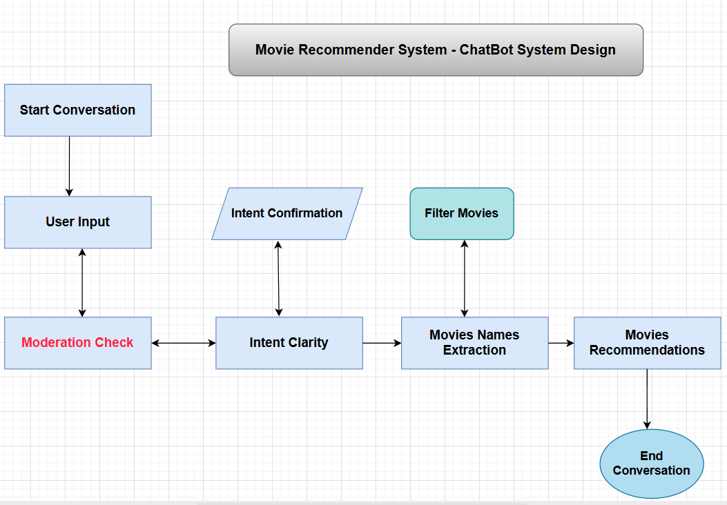

**4. Implementation:**

We will be implementing our chatbot in three different stages

Stage 1

* Intent Clarity Layer
* Intent Confirmation Layer

Stage 2

* Filter Movies Layer
* Movies Extraction Layer

Stage 3

* Movies Recommendation Layer

**4.1 : Stage 1**

Let's start with the first part of the implementation - building the intent clarity and intent confirmation layers. As mentioned earlier, this layer helps in identifying the user requirements and passing it on to the product matching layer. Here are the functions that we would be using for building these layers:

* initialize_conversation(): This initializes the variable conversation with the system message.
* get_chat_completions(): This takes the ongoing conversation as the input and returns the response by the assistant
* moderation_check(): This checks if the user's or the assistant's message is inappropriate. If any of these is inappropriate, it ends the conversation.
* intent_confirmation_layer(): This function takes the assistant's response and evaluates if the chatbot has captured the user's profile clearly. Specifically, this checks if the following properties for the user has been captured or not such as actor_name , genre, language, country etc.
* dictionary_present(): This function checks if the final understanding of user's profile is returned by the chatbot as a python dictionary or not. If there is a dictionary, it extracts the information as a Python dictionary.

**moderation_check():**

This checks if the user's or the assistant's message is inappropriate. If any of these is inappropriate, you can add a break statement to end the conversation.

intent_confirmation_layer():

This function takes the assistant's response and evaluates if the chatbot has captured the user's profile clearly. Specifically, this checks if the following properties for the user has been captured or not

* actor_Name
* movie_released_year
* genre
* language
* country

Sample code for checking IntentConfirmation:

* debug_response_assistant_2 = f"""
* Great, thank you for providing all the details.
* Based on your inputs, here is the final profile for the movies  you are looking for:
* {{'actor_Name':'Tom Cruise',
* 'movie_released_year':'2014',
* 'genre':'Action',
* 'language':'English',
* 'country':'any'}}
* """
* print(debug_response_assistant_2)
* response = intent_confirmation_layer(debug_response_assistant_2)
* response.get('result')
* Yes

dictionary_present(): This function checks if the final understanding of user's profile is returned by the chatbot is a Python dictionary or not.

**Sample Conversation of Stage 1:**

debug_conversation = initialize_conversation()

debug_user_input = "Hi, I am John. I am looking for some movie recommendations or suggestions, can you help me with that?"

debug_moderation = moderation_check(debug_user_input)

debug_conversation.append({"role": "user", "content": debug_user_input})

debug_response_assistant = get_chat_completions(debug_conversation)

debug_moderation = moderation_check(debug_response_assistant)

debug_conversation.append({"role": "assistant", "content": debug_response_assistant})

debug_conversation.append({"role": "assistant", "content": "Yes, I am looking for movies of Tom Cruise of Action genre of Year 2014 of english lanaguage of country USA"})

debug_response_assistant = get_chat_completions(debug_conversation)

debug_response_assistant

##output

{'actor_Name': 'Tom Cruise', 'movie_released_year': 2014, 'genre': 'Action', 'language': 'English', 'country': 'USA'}

**4.2 : Stage 2**

In Stage 2 we will be building the Movies Extraction layer and filter layer , based on the final output we receive from Stage1

Implementing the Filter Movies and Movies Extraction Layers

In this section, we take in the output of the previous layers, i.e. the user requirements, which is in the format of a Python dictionary.  
Next we will extract the movies recommendations based on user's requirements.

filter_movies() :

This function will take the movies data frame and a movie_dict as input which is nothing but list of user requirements in the form of json dictionary , which will be used to extract movies which matches the movie_dict values and return a Dataframe as output.

# Example usage with response_dict_2:

filtered_movies = filter_movies(movies_details, response_dict_n)

filtered_movies

Output:



Movies Extraction List :

get_movie_titles : This function will return the list of movie titles it will accept a Dataframe as input.

**4.3 : Stage 3**

The final Stage which provide the List of movies name in chatty way,with the help of open api prompts

provide_movie_suggestions() : This function accepts list of movies and returns a well-define text to the user which contains the list of recommended movies along with some some useful custom message in chatty way.

# Example usage with the filtered movie titles:

chatty_response = provide_movie_suggestions(movie_titles)

print(chatty_response)

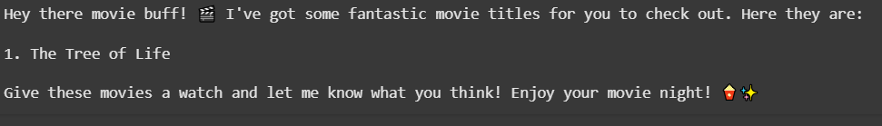

**5. Running All Stages Together Stage1+Stage2+Stage 3**

**initiate_brad_pitt_chat :** This function will have all the logic to run continuous prompt with different set of checks like moderation and provide more info to get the final output

**Sample Chat :**

user: Hi, I am John looking for some movie recommendations , can you help me with that?.

assistant: Great! As a Movie Recommender, I can provide you with great movie recommendations. To better assist you, could you please let me know if you have any specific genre or actor preferences for the movies you are looking for?

user: Hi, I am looking for movies of actor Brad Pitt from the year 2001 of Crime 'genre' of English language of 'any' country.Please provide movies with this info only nothing else

assistant: Hey there! I'm so excited to share some awesome movie recommendations with you. Here are a couple of fantastic titles for your movie night:

1. Spy Game

2. Ocean's Eleven

These movies are both packed with suspense, intrigue, and a touch of humor. I think you're in for a real treat with these choices. Enjoy watching! 🍿🎬

**6. Learning & Challenges:**

**-** Need to provide proper prompting so that the LLM Can understand our set of requirements, and extract the relevant info form the user messages.

- Bad prompting can result-in improper result

-Has to provide inputs like this to get good result:

 example_user_dict = {'actor_Name': "Value",

                      'movie_released_year':"Value",

                        'genre': "Value",

                        'language': "Value",

                        'country': "Value",

                        }

- Has to provide clear prompting such as chain of thoughts and roles to the LLM so that it can verify the details

 You are a senior evaluator who has an eye for detail.The input text will contain a user requirement captured through 5 keys.

    You are provided an input. You need to evaluate if the input text has the following keys:

    {{

    'actor_Name':'values','movie_released_year':'number','genre:'values','language':'values','country':'values'

    }}

    The 'movie_released_year' key can take only a numerical value.

    The 'country' key can take any country value of string format , also the value 'any' is accepted for this field

    Next you need to evaluate if the keys have the the values filled correctly.

    Only output a one-word string in JSON format at the key 'result' - Yes/No.

    Thought 1 - Output a string 'Yes' if the values are correctly filled for all keys, otherwise output 'No'.

    Thought 2 - If the answer is No, mention the reason in the key 'reason'.

    THought 3 - Think carefully before the answering.